H.T No
Regulations:
A20

Sreenidhi Institute of Science and Technology
(An Autonomous Institution)
Code No: 8HC12 Date:13 -August-2024 (FN)

B.Tech I-Year II- Semester External Examination, August-2024 (Supplementary)
DIFFERENTIAL EQUATIONS &INTEGRAL CALCULUS (CIVIL and MECHANICAL)

Time: 3 Hours Max.Marks:70

Note: a) No additional answer sheets will be provided.
b) All sub-parts of a question must be answered at one place only, otherwise it will not be valued.
c) Missing data can be assumed suitably.

Bloom's Cognitive Levels of Learning (BCLL)

Remember | L1 | Apply | L3 | Evaluate | L5
Understand | L2 | Analyze | L4 | Create | L6

Part - A Max.Marks:20
Answer all QUESTIONS

 |  | BCLL | CO(s) | Marks
1 | Define Linear Differential Equation and write the Integrating factor and General solution | L1 | CO1 | [2M]
2 | Find the general solution of 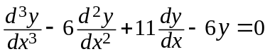 | L3 | CO2 | [2M]
3 | Form the partial differential equation by eliminating ‘a’ and ‘b’ from  z = ax + by | L2 | CO3 | [2M]
4 | Classify the partial differential equation  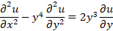 | L1 | CO4 | [2M]
5 | Evaluate | L3 | CO5 | [2M]
6 | State Gauss Divergence theorem | L1 | CO6 | [2M]
7 | Find 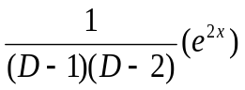 | L3 | CO2 | [2M]
8 | Solve | L3 | CO3 | [2M]
9 | Evaluate 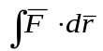where 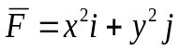and c is the curve 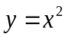in the 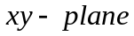 from (0,0) to (1,1). | L3 | CO6 | [2M]
10 | Solve the differential equations | L3 | CO1 | [2M]
Part – B Max.Marks:50
ANSWER ANY FIVE QUESTIONS. EACH QUESTION CARRIES 10 MARKS.

 |  |  | BCLL | CO(s) | Marks
11. | a) | Solve 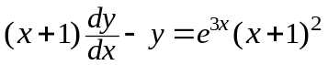 | L3 | CO1 | [5M]
 | b) | The number N of bacteria in a culture grew at a proportional to N. The value of N was initially 100 and increased to 332 in one hour. What was the value of N after 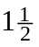hours? |  | CO1 | [5M]
12. | a) | Solve the differential equation | L3 | CO2 | [5M]
 | b) | Solve the differential equation by the method of variation of parameters | L3 | CO2 | [5M]
13. | a) | Solve | L3 | CO3 | [5M]
 | b) | Solve. | L3 | CO3 | [5M]
14. |  | A uniform string is stretched and fastened between two points ‘l’ apart motion is started by displacing the string in the form of a cure and then released at form this position at time t=0. Find the displacement of the string at the point at a distance ‘x’ from one end at time ‘t’ | L3 | CO4 | [10M]
15. | a) | Evaluate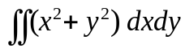 in the positive quadrant for which 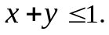 | L3 | CO5 | [5M]
 | b) | Evaluate 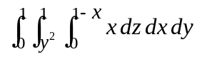 | L3 | CO5 | [5M]
16. |  | Verify Green’s theorem for 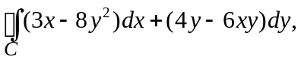where C is the boundary of the region bounded by 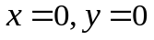and 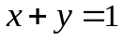 | L4 | CO6 | [10M]
17. | a) | Solve the differential equation | L3 | CO1 | [4M]
 | b) | Solve | L3 | CO2 | [3M]
 | c) | Form the partial differential equation by eliminating an arbitrary function from. | L2 | CO3 | [3M]
18. | a) | What are the boundary conditions and initial conditions of one-dimensional Heat equation. | L1 | CO4 | [4M]
 | b) | Evaluate | L3 | CO5 | [3M]
 | c) | State Stoke ’s theorem | L1 | CO6 | [3M]
-- 00 -- 00 –

